A000-Asia-China-Hongshan-Liaoning-Pig Dragon-Jade-紅山 - 遼寧 - 豬龍-玉-6.75 in

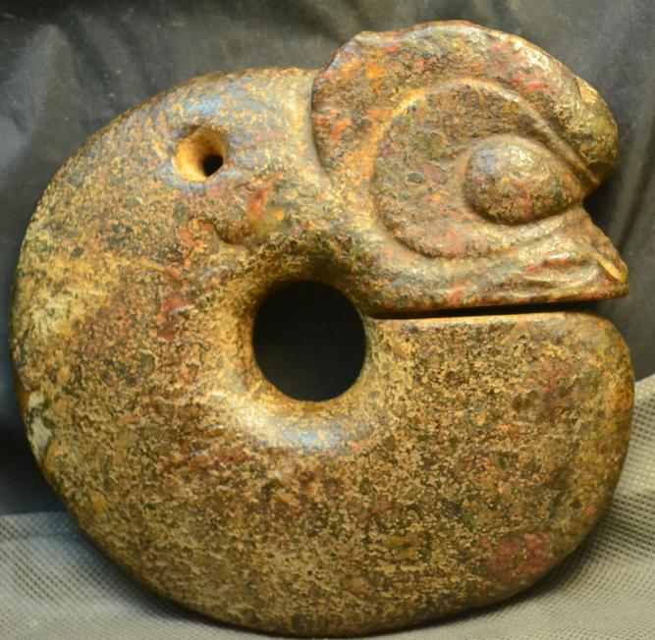

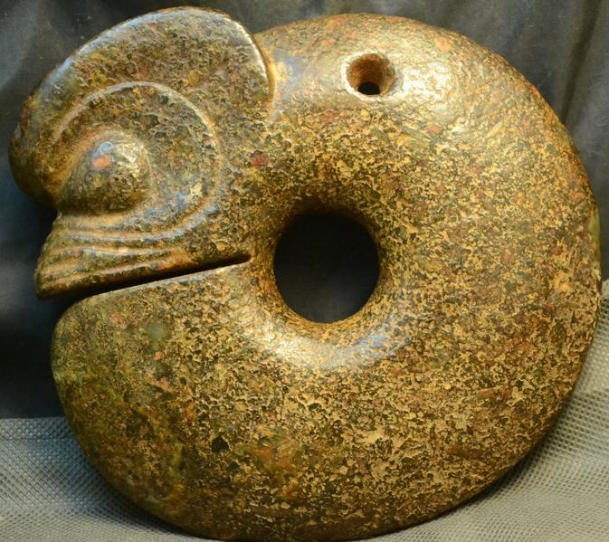 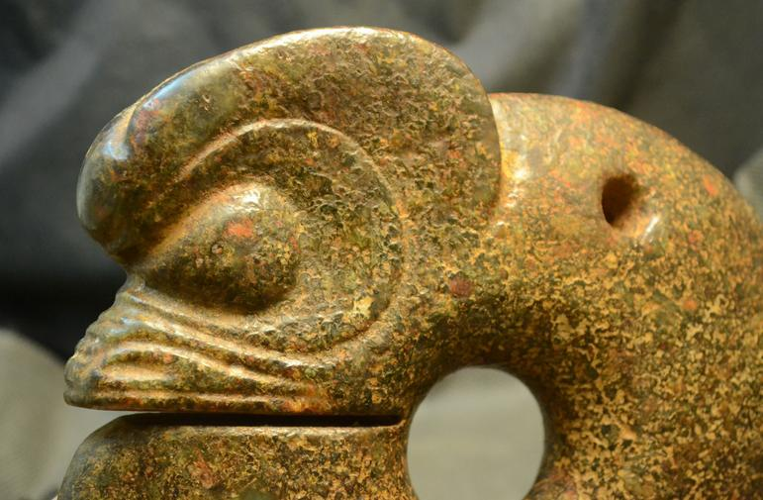 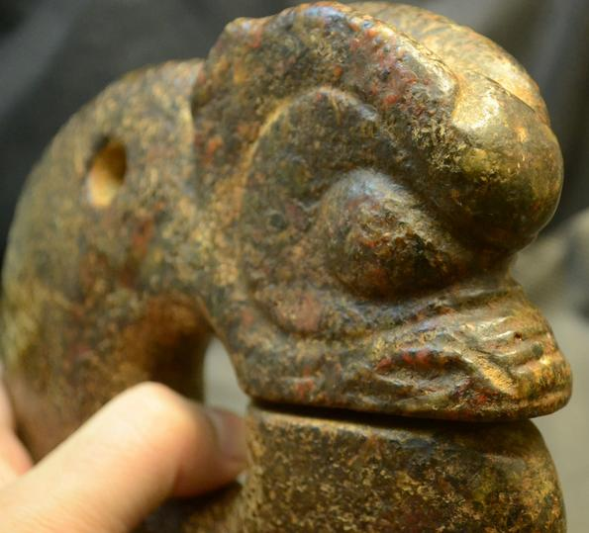 SHAPE \* MERGEFORMAT 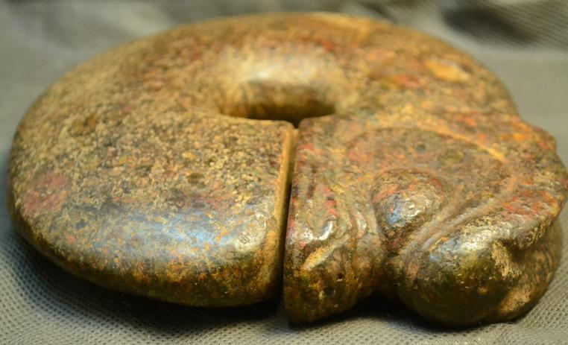 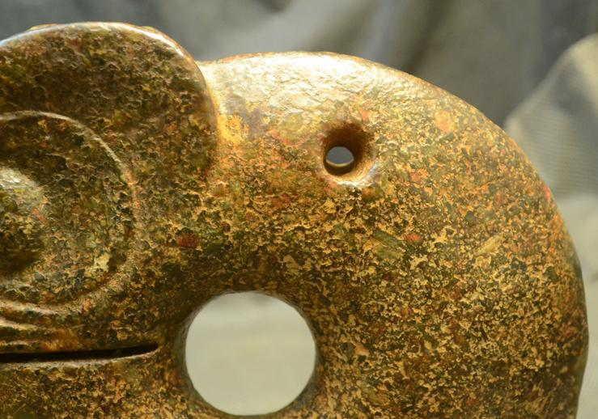 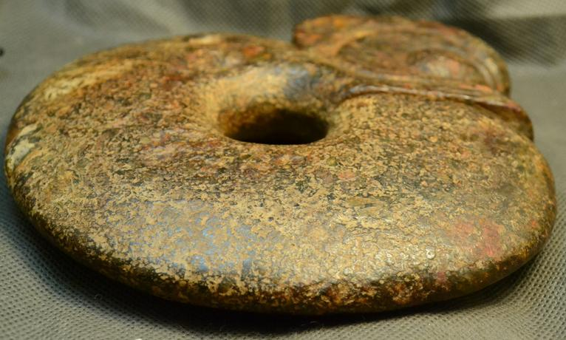 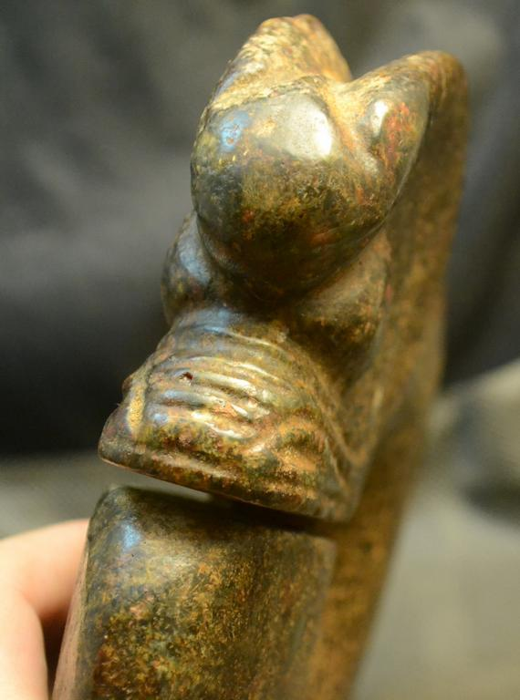 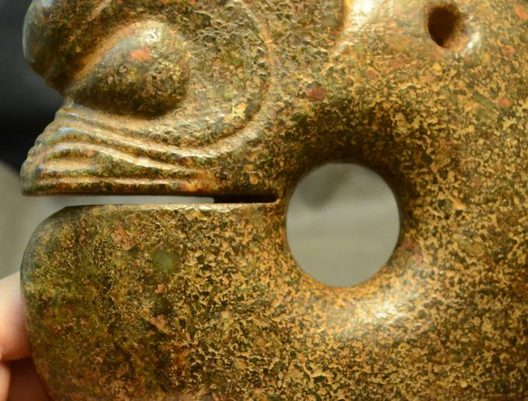

Figs. 1-3. Hongshan-Liaoning-Pig Dragon-Jade-紅山 - 遼寧 - 豬龍-玉-6.75 in

Case no.: 5

Accession Number: A000

Formal Label: Hongshan-Liaoning-Pig Dragon-Jade-紅山 - 遼寧 - 豬龍-玉-6.75 in

**Display Description:**

This Hongshan Pig-dragon jade carving from Liaoning (紅山-玉--豬頭龍--建平--遼寧)is a zoomorphic, figurine with a pig-like snout and pointed ears on an elongated, "suggestively fetal” or serpentine, limbless body, coiled around a central axis (see Childs-Johnson 1991). Early Hongshan pig-dragon jade carvings (ca 5000 BCE) have stout, pig-like bodies, while later Hongshan examples (ca 3000 BCE) have slender, serpentine bodies. Since pig-dragon jade carvings have been excavated as Hongshan grave goods (Howard 2006), and since pig bones have accounted for 60 percent of animal bones recovered from Hongshan sites, it is inferred that pigs were important not only for the Hongshan economy but also for their symbolic significance. The melding of a fetal-serpentine shape with that of a pig may have been intended to couple an ancient dragon-serpentine shape with that of an economic icon producing a powerful Hongshan foundational image.

The Shang (ca 2000 BCE) written sign for a dragon 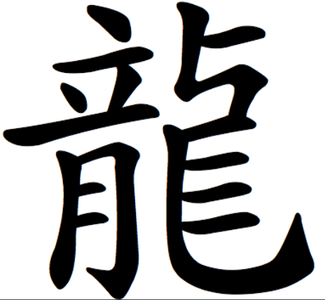 , incorporates motifs. For instance, the top of the emperor’s tall crown is capped with a dragon’s horn**立** resembles the and also symbolizes an, **月** portrays a large open mouth with two big front teeth inside, and 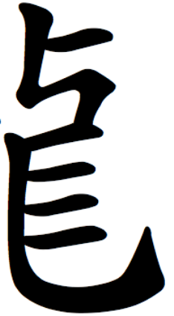 **>** depicts a head , a 4-legged body  and a tail .This Shang glyph incorporates a 4-legged body which is legless and serpentine in Hongshan pig-dragon images.

**LC Classification:**

Date or Time Horizon:

Geographical Area: Liaoning Province

**Map:**

**GPS coordinates:**

Cultural Affiliation: Hongshan

Medium: jade

Dimensions: H 4.5 in, W4.5 in

Weight:

Condition: original

Provenance: Jianping

**Discussion:**

**References:**

Childs-Johnson, Elizabeth (1991). "Jades of the Hongshan culture: the dragon and fertility cult worship," Arts asiatiques, **46**: 82–95.

Salviati, Filippo (2002). *The Language of Adornment: Chinese Ornaments of Jade, Crystal, Amber and Glass*, Fig. 17. Ten Speed Press.